Paper Bride 7 Lethal Bond Chapter 1 Full Puzzle Solutions
Welcome, brave players, to Paper Bride 7: Lethal Bond – Chapter 1! In this chapter, you will experience the joy of feeding strangers weird stew from a coffin, throwing shoes into a river like an offering to the RNG gods, fixing statues based on how many arms they have, and dealing with a blind box machine that's honestly more exciting than real-life gachas.
If you've already started doubting your IQ, your luck, or even your life choices… relax. We've all been there. Take a deep breath, follow this guide, and let's survive this chapter together with dignity—well, whatever is left of it.
目录

Puzzle Breakdown

【Shopping Street】Snack Stall
1.After the opening cutscene, a new message appears in the "Wordless Prophecy" (book). The illustration indicates a connection to the snack stall on the left.
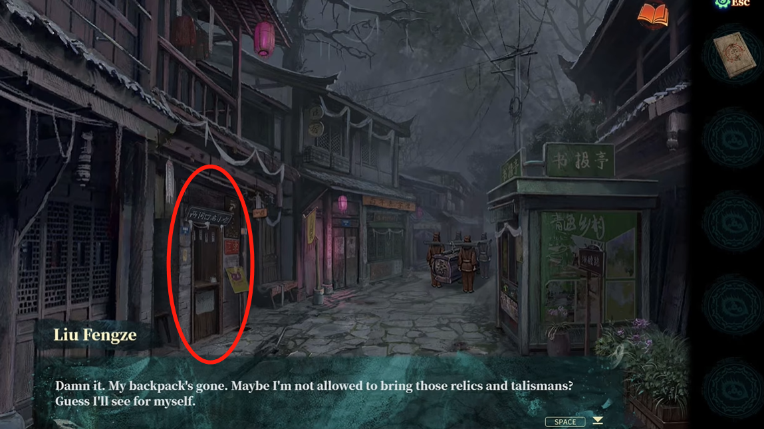
2.Based on the prophecy hints:
"1" is Four Sacrifices (四牲)
"3" is Seeds (子)
"2" and "5" are Paper Dust (楮尘)
"4" is Underworld Money (冥镪)
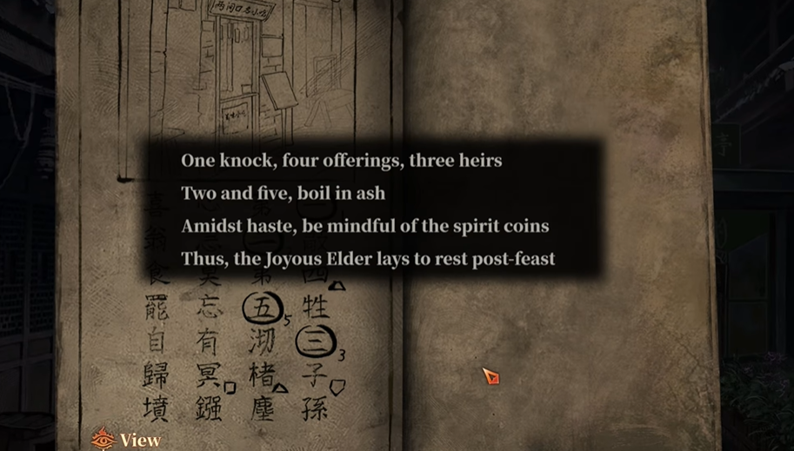
3.Click the food signs above the snack stall in the correct numerical order to obtain [Paper Dust Paste].「Ash Stew」。
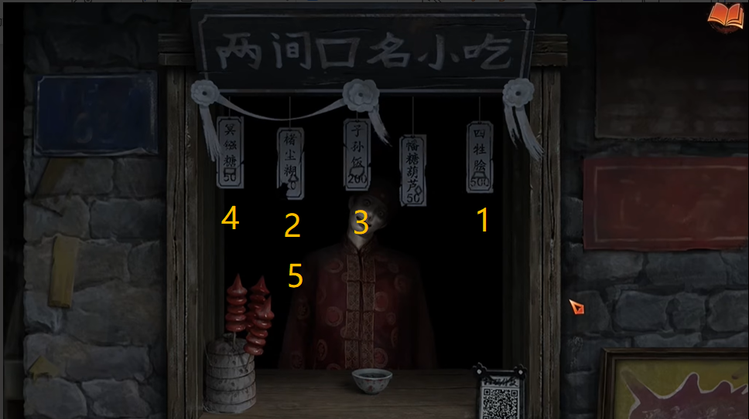

【Shopping Street】Coffin Bearers
1.Talk to the coffin bearers. A Happy Elder's hand will reach out from inside the coffin.
2.Give the Ash Stew to him to receive an Ancient Coin and a new prophecy clue. You can now proceed to the Square.
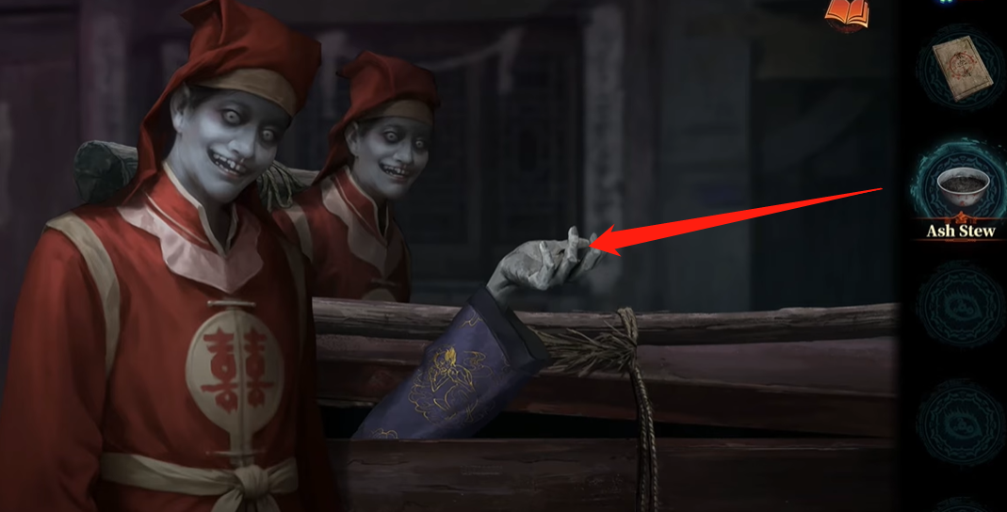
3.Reopen the prophecy book to check the newly added hint. After closing the book, walk forward along the street to reach a new area.
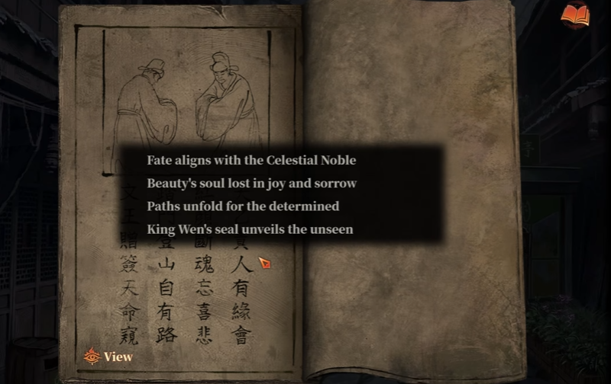

【Square】Blind Box Machine
1.Insert the Ancient Coin into the blind box machine to obtain a Six-armed Statue and Longevity Shoes.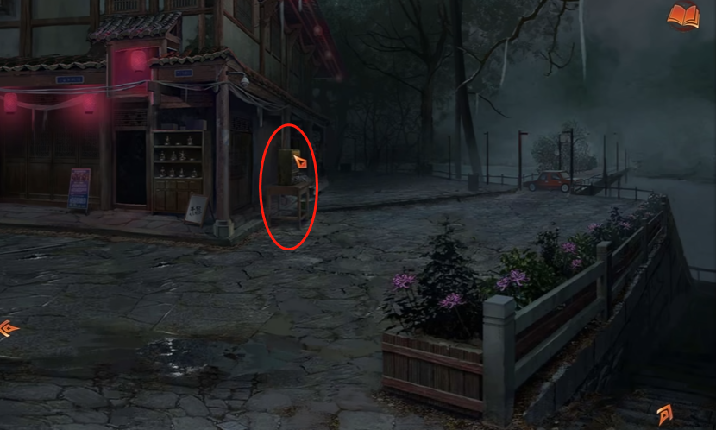
2.Throw the Longevity Shoes into the river to receive a Wig and a Tie.
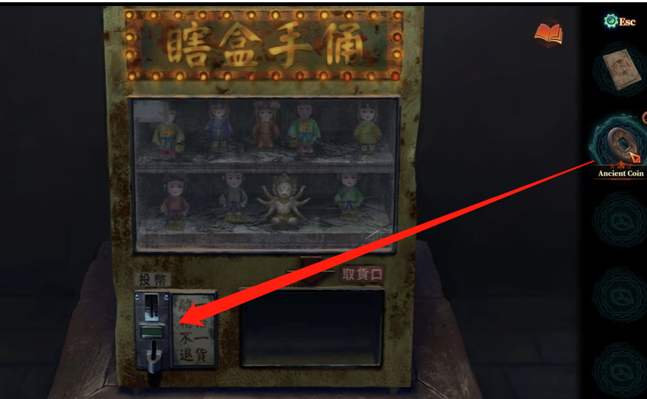

【Riverbank】"No Drowning" Notice Board
Throw the Longevity Shoes into the river to receive a Wig and a Tie.
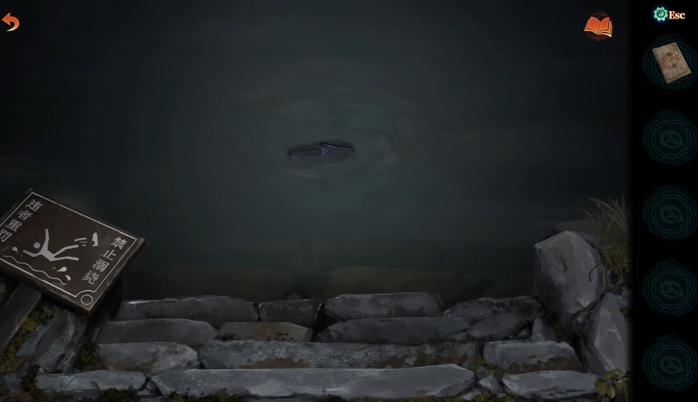

【Shopping Street】Broken Flagpole
Use the Tie to fix the almost-broken flagpole. The nearby door will open, and you will receive a One-armed Statue.
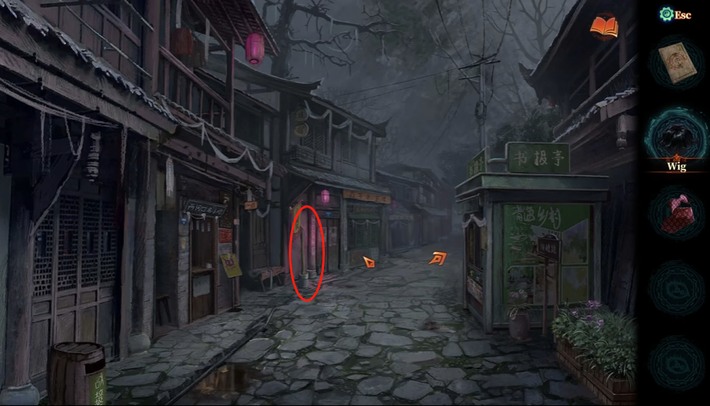

【Square】Left-side Statue Stand
1.Place both statues on the stand.
2.Inspect the paper vehicle at the back to obtain a temporary parking phone number: 144 2632 5444.
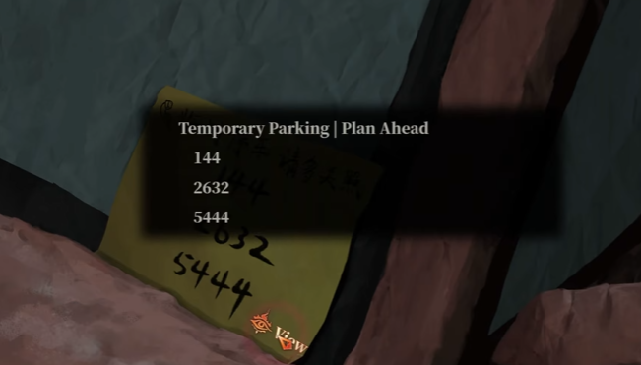
3.Observe the statues carefully. The number sequence represents the number of arms. Move the statues according to the hint. After solving, the paper car leaves. Pick up a Paper Ingot where it was and proceed to Kuique Pass Gate.
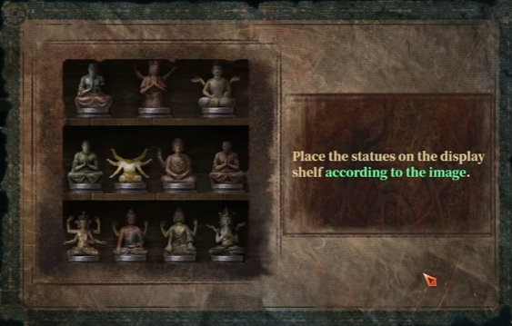

【Kuique Pass Gate】Left Fence Pendants
- Observe the dance on the Square. Different colored lights correspond to different dance moves.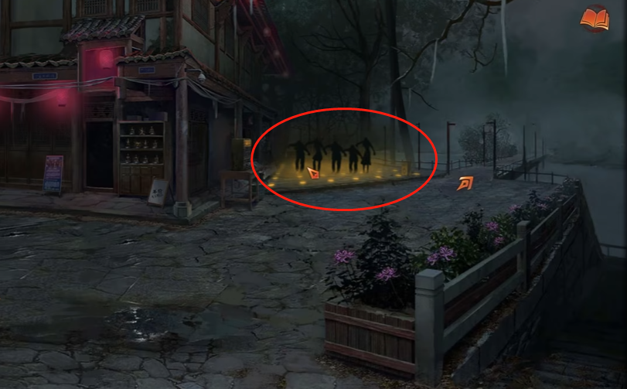
- Match the pendant colors according to the light-movement correspondence. After completing the puzzle, take the Toy Car from the basket below.
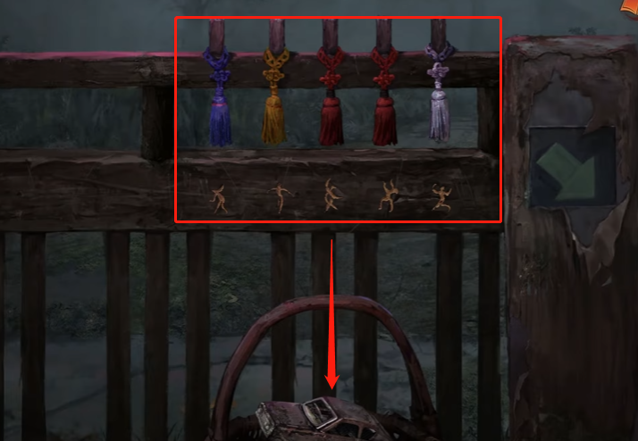

【Kuique Pass Gate】Tourists Taking Photos
1.Give the Wig to the man and the Toy Car to the child.
2.Tap the phone on the tripod to take their photo. You will receive Joss Money afterward.
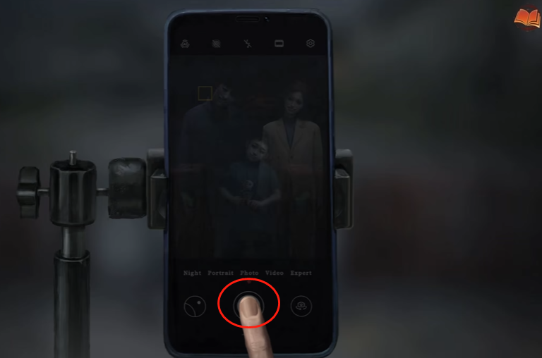

【Kuique Pass Gate】Gate Entrance
1.Return to the [Shopping Street] to trigger a cutscene. During the scene, exchange the Joss Money for Joss Candy. Check the item description for the "Joss Candy"—it notes that it is "Candy in the shape and size of a coin", meaning it can be used as currency.
2.Go to the [Square] and insert the Joss Candy into the Blind Box Machine to obtain the Ticket.
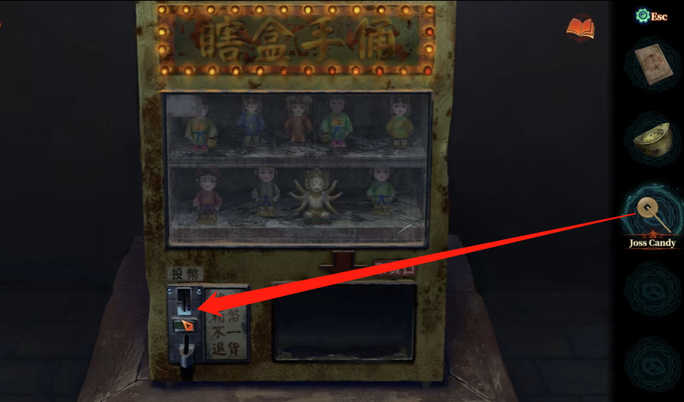
3.Use the Ticket to pass through the gate and enter the Mountain Path.
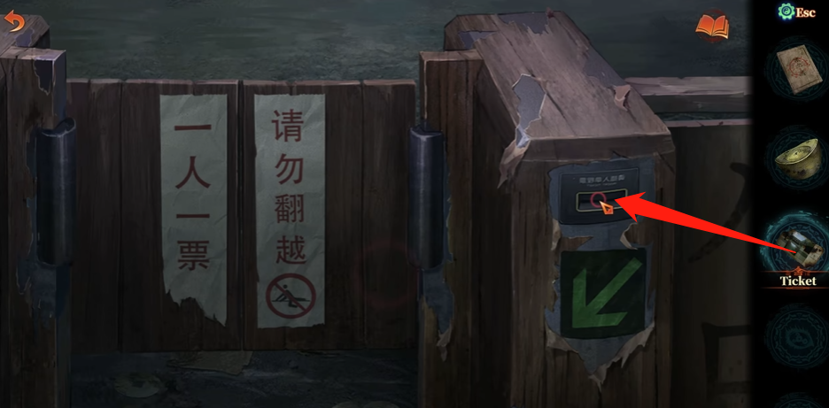

【Mountain Path】Offering Table
1.Place the Paper Ingot on the offering table to start a mini-game.
2.Stack the five ingots in order of size within the central circular area.
3.Complete it to receive a clue.
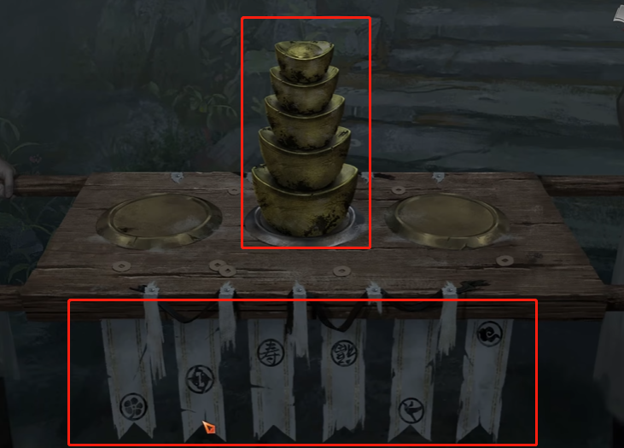

【Mountain Path】Bridal Sedan Chair Hanging Ornaments
Finishing a Offering Table game，Using the clue gained:
1.Adjust the heights of the hanging ornaments according to the hint.
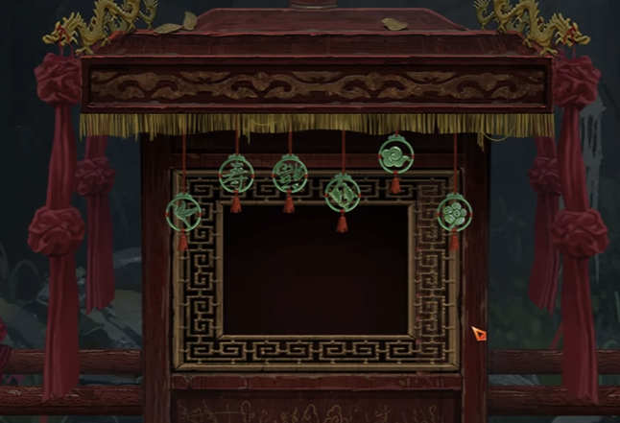
2. After solving, the sedan chair leaves. Take the Memorial Photo from the mourner's hand.
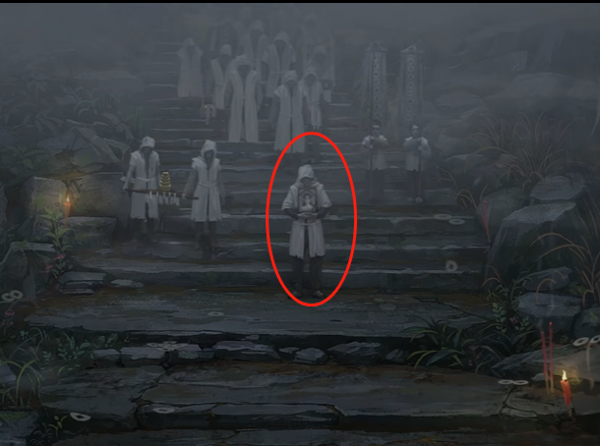

【Kuique Pass Gate】Vendor (Yan Buliu)
1.The flag behind him hints: "The Book of the Dead can be exchanged for one item."
2. Give the Memorial Photo to the vendor in exchange for a Portable Fan.
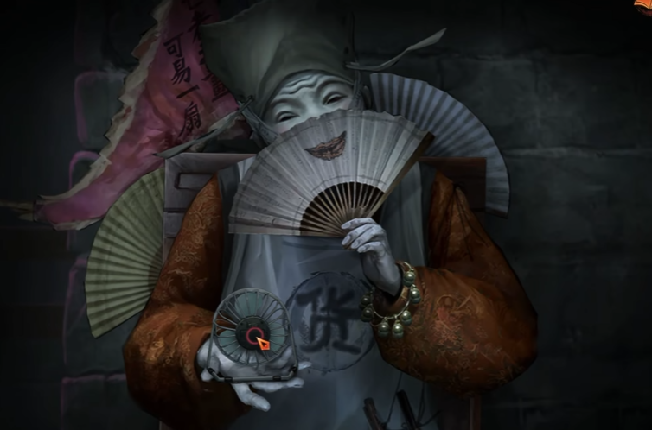

【Shopping Street】Newsstand
1.Place the Portable Fan to blow the signboard aside, allowing access to the newspapers.
2. Read "Ba Bu Lang" and "Liang Jian Kou Daily" to obtain clues about the white funeral banners.

【Mountain Path】White Banners
From the newspapers:
Boy's banner:节哀顺变，恭喜发财
Girl's banner:欢迎光临，一路走好
According to this information, rearrange the text on the white banners. The child on the right with bangs is the girl.
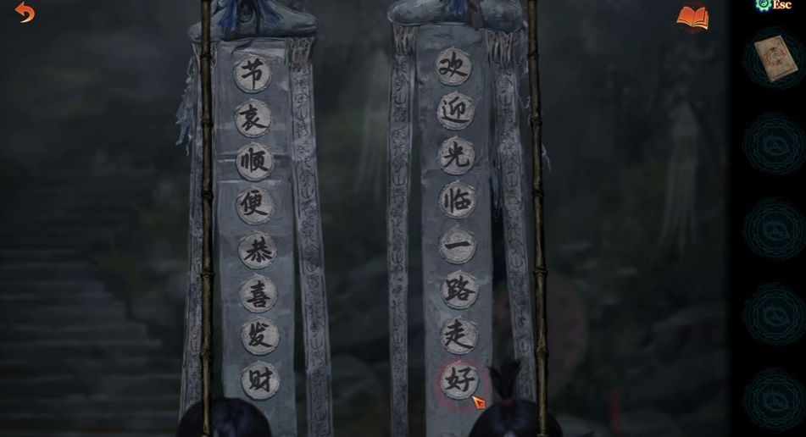

Conclusion
If you cleared this without getting stuck, you are officially big brain material. If you relied on this guide to get through… honestly? Same. Wisdom is knowing when to stop struggling and start copying.
But don't get too comfy—things are only going to get stranger, darker, and somehow funnier from here. So buckle up, keep your sanity close, and if the next chapter breaks your brain again, you already know where to find your reliable "guide spirit."

