Dragon Traveler Intermediate Training Camp Guide
If you're trying to survive (and keep your sanity) through Dragon Traveler's Intermediate Training Camp, this is the no-nonsense, mildly unhinged walkthrough for Stages 1–9.
Follow these strats, press your buttons in roughly the right order, and you'll clear the camp with fewer retries, fewer sighs, and only moderate emotional damage.

Level 1–3: Elemental Reactions

Elemental Reaction 1: Chill + Ignite → Evaporation

Goal: Stack elemental effects to trigger evaporation.
Strategy: Apply Chill first, then ignite the target. The reaction will deal enough damage to defeat most mobs.
Tips:
Forest Lord's Overdrive can apply Chill. Fire Whelp's Dragonmight canapply Ignite.
Timing is critical — the damage window is tight, so ensure your elemental applications are sequential.

Elemental Reaction 2: Ignite → Detonation
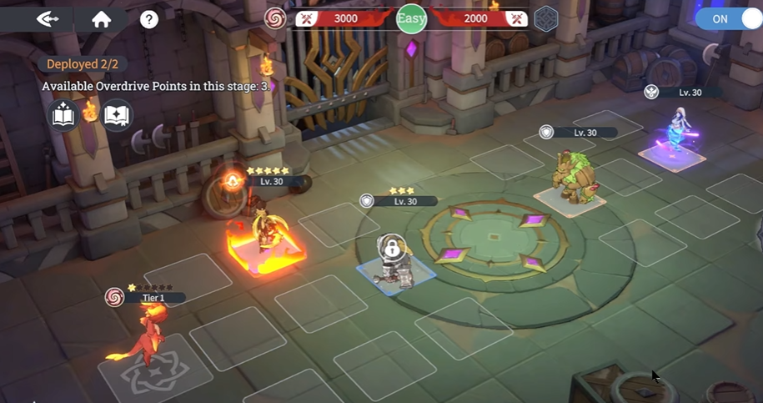
Goal: Defeat backline enemies quickly.
Strategy:
Move your Ronin forward to target the backline.
Trigger Ignite, then immediately follow with Detonation.
Slowly grind the tank at the front.
Tips:
Shadow Ronin's Overdrive canapply Shock. Fire Whelp's Dragonmight canapply lgnite.
Detonation will instantly kill backline mobs, allowing your team to focus on the tank.

Elemental Reaction 3: Flash Freeze Combo
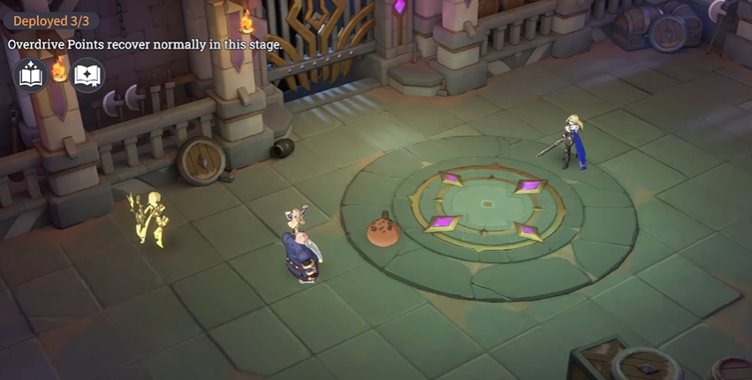
Goal: Control enemy attacks while dealing damage.
Strategy
Wait for the enemy skill animation to begin.
Interrupt the skill and combo with your own abilities.
Apply Flash Freeze to slow attack speed.
Tips:
Radiant Elemental's Overdrive caninterrupt enemies while alsoinflicting Shock. Dwarven Sage's Overdrive can inflict Freeze. Try to trigger Flash Freeze to slow down.

Level 4: Wild Status

Effect: Enemies gain rage while losing HP.
Strategy:
Use a healer to sustain your tank.
Deploy your dragon's healing aura for extra survivability.
Let your spinning damage units eliminate backline mobs.
Tip:
Some Luminaries from the WilcSpirit faction gain Rage whenlosing HP and enter the Wild statewhen Rage is full. These Luminanes experience a significant boost in copbat abilities while in the Wild state,so it is necessary to use some healing skills to ensure their survivability.

Levels 5–6: Mana Awakening

Mana Awakening 1
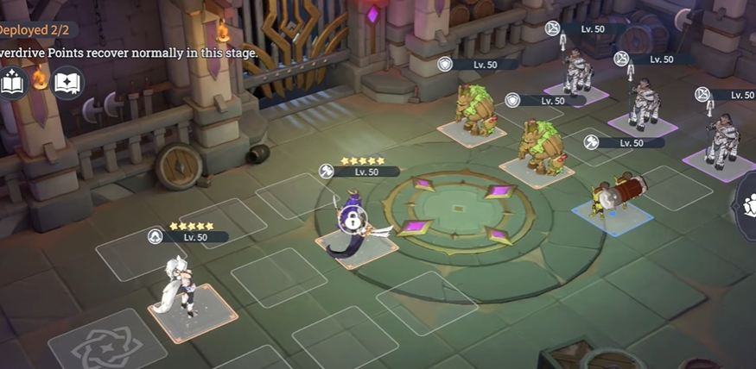
Strategy:
Use Marilus as a shield target.
Fenra deals sequential kills to all mobs.
Tip: Slightly overkill on the last mob ensures no enemies survive.
Some Arcane Wisdom Faction Luminaries gain l stack of Awakening when an allyunleashes an Overdrive. Six
Armed Serpent can consume 1stack of Awakening to launch anadditiortgl Blade Dance. Try to utilize the refresh mechanism of Night Huntress to trigger Awakening multiple times.

Mana Awakening 2
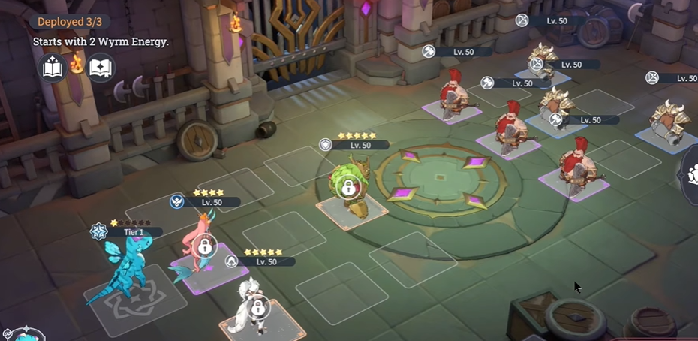
Strategy:
Fenra takes out priority targets.
Deploy dragon welps strategically for additional damage.
Ensure no key mobs survive.
Tip: This level can be tricky; timing and positioning are critical.
Wandering Songstress can consume 2 stacks of Awakening tounleash an enhanced version of Healing Hands. The higher the Wyrm Energy consumed by Little Blue Dragon's Dragonmight, the greater the damage. Try to utilize the refresh mechanism of Night Huntress to cast Overdrive multiple times to increase the skill power of Wandering Songstress and Butterfly Whelp.

Level 7: Gray Status
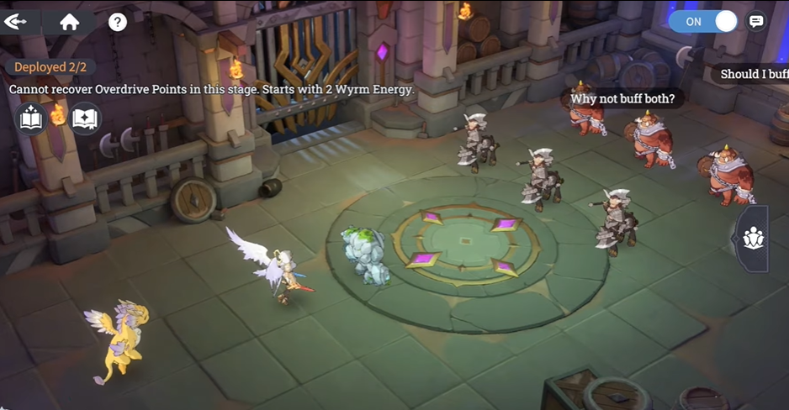
Effect: Buffs applied to your units increase damage output.
Strategy:
Position units close together.
Use Light Dragon buffs to finish off all enemies.
Tip: Watch Gabriel closely, as he may get overwhelmed if buffs are mismanaged.
Some Sanctum Glory factionLuminaries enter a Grace statuswhen they simultaneously gain Morale and Fervor. These Luminanes experience a significant boost in combat abilities while in the Grace status. The Light Whelp's Dragonmight can provide Fervor, helping our Luminaries
enter the Grace status earlier.

Level 8: Baron & Whisper of the Deathless
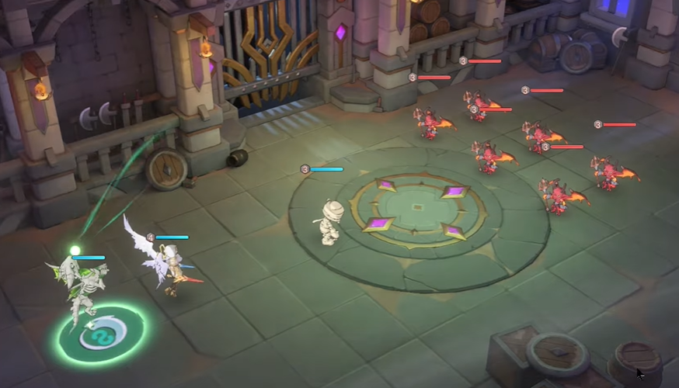
Baron
Strategy: Calculate cumulative damage carefully. Slight overkill ensures completion.
Whisper of the Deathless
Strategy:
Gabrielle consumes Death Rattle.
Summon skeleton dragons and wait for them to die first.
Gabrielle triggers her skill for maximum effect.
Tip: This stage relies on timing sacrifices correctly to maximize Gabrielle's damage.
Some Otherworld Return faction Luminaries gain l stack ofDeathrattle when our units aredefeated. The passive skill of the Archangel can significantly increase Overdrive skill damage byconsuming Deathrattle. The Shadow Whelp's Dragon Might can summon dragon summons to helpour side stack Deathrattle layers more quickly..

Level 9: Phantom Assault & Final Ronin
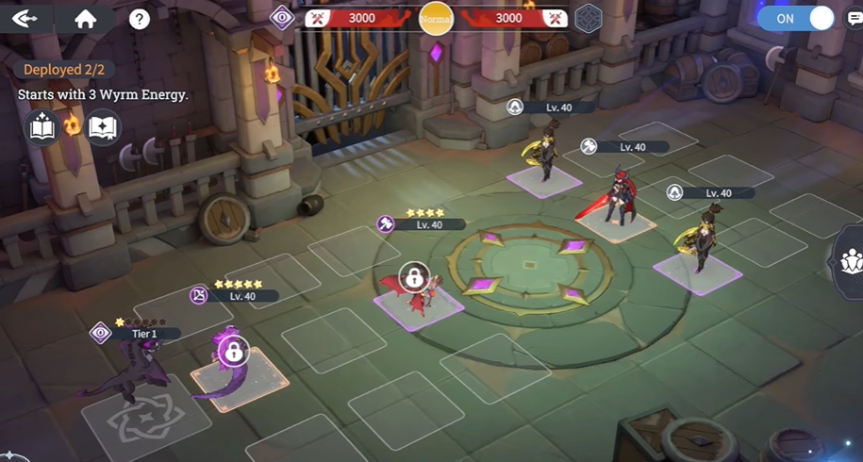
Phantom Assault + Final Ronin
Strategy:
- Use your dragon skill first.
- Delay slightly, then trigger Petrify.
- Finish all mobs efficiently.
- Deploy as the last unit to clear remaining mobs.
Tip:
- Timing the dragon skill before Petrify ensures you maximize damage output.
- Make sure prior units have completed elemental combos and buffs for minimal resistance.
Gorgon's Overdrive applies Petrifywhen hitting a target with Overdrive Energy Cost>=4. Dark Whelp's Dragonmight can increaseenemy's Overdrive Energy Cost. Utilize Dark Whelp's energy costincrease mechanism to help Gorgon petrify enemies.

Final Tips for Intermediate Training Camp
Always apply elemental effects first, then trigger reactions to maximize damage efficiency rather than activating skills randomly.
Use dragons and healers with clear intent, focusing on sustain and survivability instead of rushing damage.
Pay close attention to unit positioning, as proper placement directly affects AoE coverage, buff application, and enemy targeting behavior.
Skill timing is critical—well-timed interrupts, stuns, and ultimates determine whether combos succeed or fail.
Finally, repeat each stage deliberately to learn enemy patterns, reaction windows, and optimal execution timing; consistency comes from understanding, not luck.

Conclusion
The Dragon Traveler Intermediate Training Camp is not about difficulty, but about understanding how the game wants you to play. By mastering elemental reactions, positioning, and skill timing, you will not only clear the training camp but also perform better in real combat scenarios.
If you are still struggling, rewatch the mechanics carefully and practice execution—every stage is consistent once understood.

